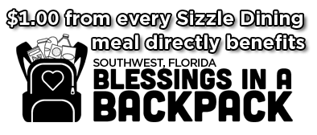
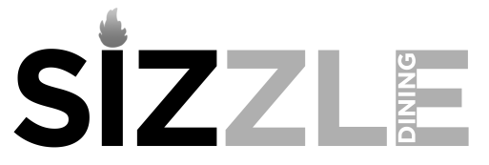
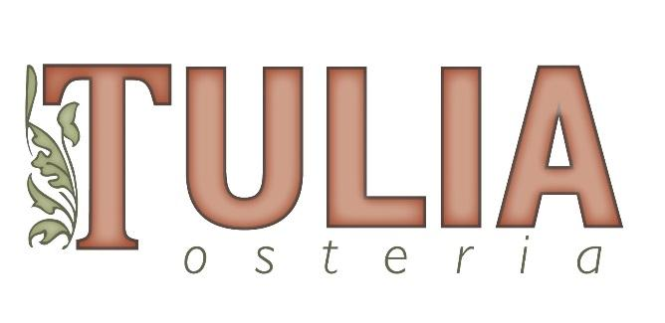

Sept 9th – 29th 2021

Two Course Lunch $24.00 per person
Beverages, Gratuity + Tax not included
Choice of one dish from each course
…………………………….…………………………………………………

Primi
Mista
farm greens, radishes, asparagus, red onion, carrots & manchego cheese

Caesar
romaine lettuce, anchovy-garlic dressing & parmigiana

Prosciutto & Melon Salad
avocado, ricotta salata & chili oil, purslane

Secondi
My Michelle Pizza
pepperoni, shishito pepper, ricotta, caramelized onion & honey

OT Butter Burger
stewed onion, pickle, American cheese & butter

Spaghetti ft Meatballs
tomato, basil & parmigiana

Garganelli Pasta
slow-braised lamb sugo & pecorino romano

Oven Roasted Salmon
spinach, sultana, pine nuts & citrus butter

Roasted Turkey Sandwich
bacon, provolone, red onion, mayonnaise & avocado

Wood Grilled Chicken Thighs
tomatoes, cucumbers, red onions & watercress

